KNN Regression
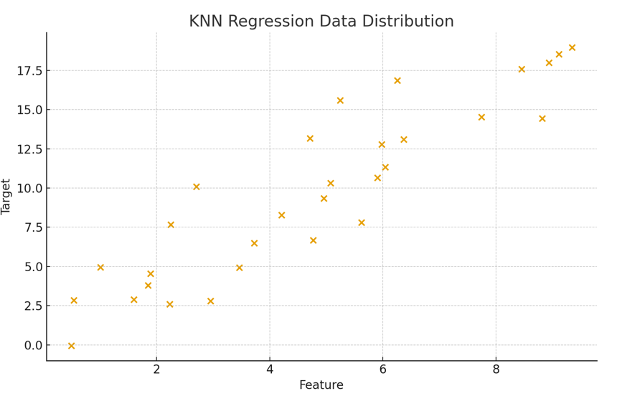

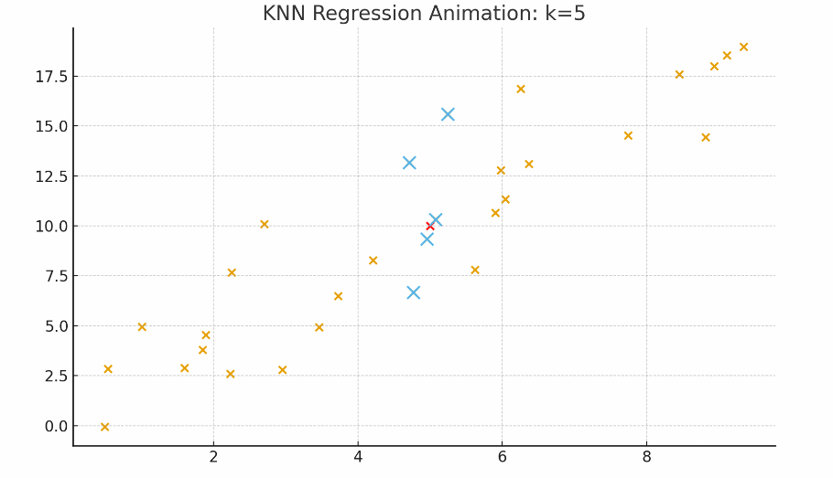

Questions
1. KNN Regression predicts the value for a new point by:
A. Taking the majority class of neighbors
B. Taking the average of the nearest neighbors
C. Taking the median of the nearest neighbors
D. Summing neighbor values

2. In KNN Regression, the parameter K refers to:
A. Number of features
B. Number of clusters
C. Number of nearest neighbors to consider
D. Number of iterations

3. Which metric is commonly used to measure distance in KNN?
A. Manhattan distance
B. Euclidean distance
C. Minkowski distance
D. All of the above

5. What happens when K is too small?
A. Model becomes too simple
B. High bias
C. High variance (overfitting)
D. No change

6. What happens when K is too large?
A. Model becomes very complex
B. Model becomes smoother but may underfit
C. Distance cannot be computed
D. Dataset must be scaled

7. Scaling features before KNN is:
A. Optional
B. Not needed
C. Necessary
D. Harmful

8. Which distance metric is MOST commonly used by default in KNN?
A. Manhattan
B. Minkowski
C. Euclidean
D. Cosine

9. KNN Regression predicts continuous values whereas KNN Classification predicts:
A. Words
B. Numbers
C. Categorical labels
D. Sentences

Regression Metrics
- MAE – Mean Absolute Error

y

x
We don’t consider the sign
Values Range = 0 – infinity
0 being the best value

Advantage
Same unit as y (can easily communicate the loss)
Robust to outliers

Disadvantage
non-differentiability at zero, which can complicate optimization

- MSE – Mean Square Error

Values Range = 0 – infinity
0 being the best value

Advantage
Solves the issue with MAE

Disadvantage
Unit will be y2 (difficult to communicate the loss)
Not Robust to outliers

If you have less outliers go with MSE, if more outliers go with MAE

RMSE

Rmse = square root of mse

Values Range = 0 – infinity
0 being the best value
Advantage
Same unit as y (can easily communicate the loss)
Disadvantage
Not Robust to outliers

These are called loss or error functions
They depend on context
Example – 1.5 error in million dollars is fine
But 1.5 error in steering angle is bad can cause accident

R2 Score
Tells how well your model performs

Also called coefficient of determination/ goodness of fit

SSr = Sum of Square error (regression line)
SSm = Sum of Square error (mean line)

If r =0
That means error (right hand side) should be 1
That means our regression line is overlapping our regression line
This is worst performance

If r = 1
That means error (right hand side) should be 0
That means our regression line is not doing any mistake (error is 0)
This is best performance

Your R2 score should go towards 1 and not towards 0

R2 score = -negative
Your regression line is performing worst than then the mean line

That means you did not understand the data
Example – applying linear regression on non linear data

R2 = 0.80
Model is able to explain 80% variation in package variance

Model is able to explain variation in the target column from the input columns
Data context have no effect

Adjusted R2 score
More input columns can increase the R2 score
Example – cgpa explaining 80% variance in Package
Cgpa and iQ can explain 90% variance

Sometimes irrelevant columns can have no impact on the R2 score or can increase R2 score where it needs to decrease.

So we have adjusted R2
Formula
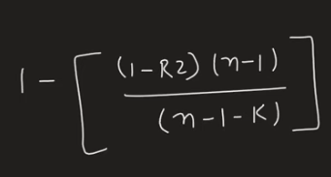
R2 = R2 score
N = rows of data
K = no of features/ columns

It is more reliable

